
US INDUSTRY STATE REPORT IL48831
Port & Harbor Operations in Illinois
March 2026



State Industry Report

Industry Performance

Establishments
The number of Port & Harbor Operations establishments in Illinois accounts for 3.6% of the 331 establishments within the national industry, ranking Illinois 10th for the number of industry establishments within the US.
Port & Harbor Operations in Illinois #10 in Highest Establishments  12 Establishments (2026) -1.6% Annual Growth (2021-26) 1.6% Annual Growth (2026-31) |  | Port & Harbor Operations in the US  331 Establishments (2026) -1.1% Annual Growth (2021-26) 0.9% Annual Growth (2026-31)

Revenue
Port & Harbor Operations in Illinois contributes 1.7% to the total national industry's revenue of $6.0 billion, ranking Illinois 12th out of 45 states in total industry revenue.
Port & Harbor Operations in Illinois #12 in Highest Revenue 1.7% of state's GDP  $101.6m Revenue (2026) 3.5% Annual Growth (2021-26) 1.9% Annual Growth (2026-31) |  | Port & Harbor Operations in the US  $6.0bn Revenue (2026) 3.6% Annual Growth (2021-26) 2.7% Annual Growth (2026-31)

Employment
Employment for Port & Harbor Operations in Illinois totals an estimated 298 which increased an annualized 3.8% over the past five years. Illinois employs the 11th-most employees nationwide.
Port & Harbor Operations in Illinois #11 in Most Employment  298 Employment (2026) 3.8% Annual Growth (2021-26) 2.4% Annual Growth (2026-31) |  | Port & Harbor Operations in the US  15,046 Employment (2026) 3.5% Annual Growth (2021-26) 2.4% Annual Growth (2026-31)

Wages
Total wages for Port & Harbor Operations in Illinois amount to $25.9 million, which increased an annualized 2.6% over the past five years. The average wage of Port & Harbor Operations employees in Illinois is $86,906, which is 7.1% higher than the industry's national average wage of $81,158.
Port & Harbor Operations in Illinois #11 in Highest Wages  $25.9m Wages (2026) 2.6% Annual Growth (2021-26) 2.7% Annual Growth (2026-31) |  | Port & Harbor Operations in the US  $1.2bn Wages (2026) 2.5% Annual Growth (2021-26) 2.5% Annual Growth (2026-31)

Current Performance & Outlook | The Port & Harbor Operations industry in Illinois is expected to grow an annualized 3.5% to $101.6 million over the five years to 2026, while the national industry will likely grow at 3.6% during the same period. Industry establishments decreased an annualized -1.6% to 12 locations. Industry employment has increased an annualized 3.8% to 298 workers, while industry wages have increased an annualized 2.6% to $25.9 million.  Over the five years to 2031, the industry is expected to grow an annualized 1.9% to $111.7 million, while the national industry is expected to grow 2.7%. Industry establishments are forecast to grow 1.6% to 13 locations. Industry employment is expected to increase an annualized 2.4% to 336 workers, while industry wages are forecast to increase 3% to $29.6 million.
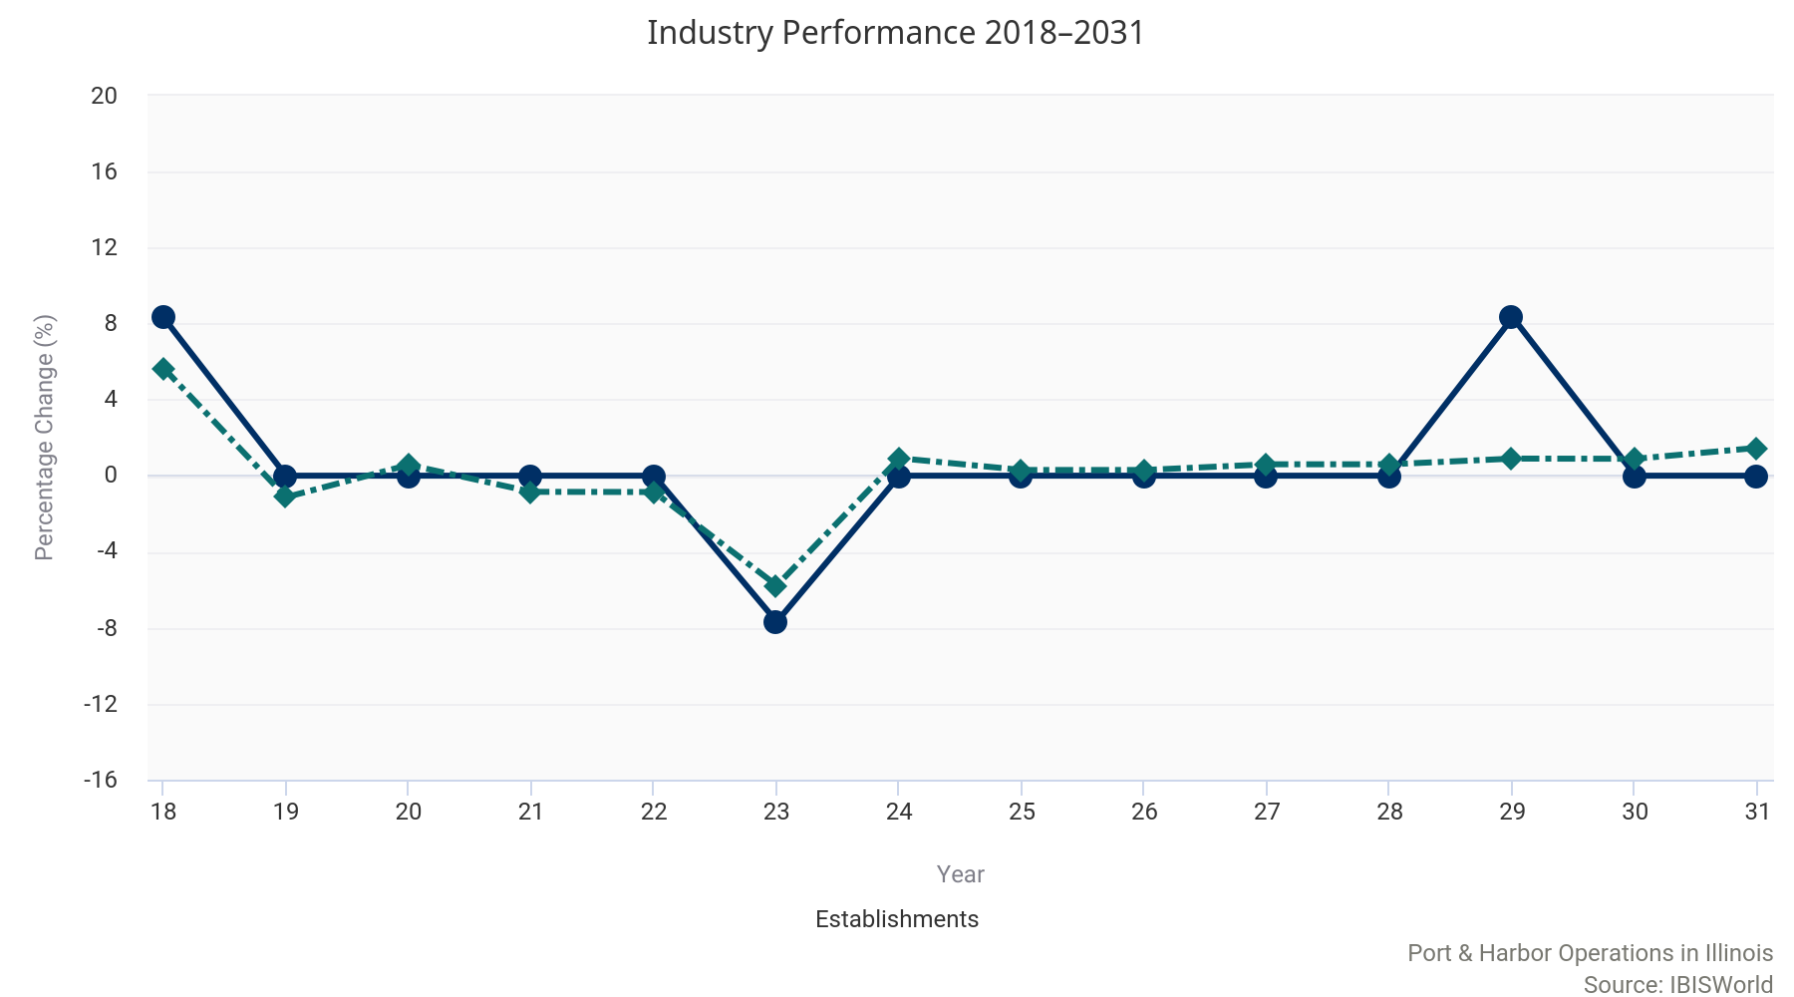
Port & Harbor Operations in Illinois

Port & Harbor Operations in the US

Key External Drivers | Every industry encounters external factors that impact industry performance. In addition to the three most influential national key external drivers of an industry, we have identified key state level indicators that are likely to impact the local industry's performance.

Illinois Economic Indicators  0.2% Population 11.6% Unemployment Rate -1.0% Private Investment in Non-Residential Construction  View more state economic information in the IL State Economic Profile. |  | US Key External Drivers  0.5% Total trade value 2.1% Consumer spending 3.8% Freight transportation services index
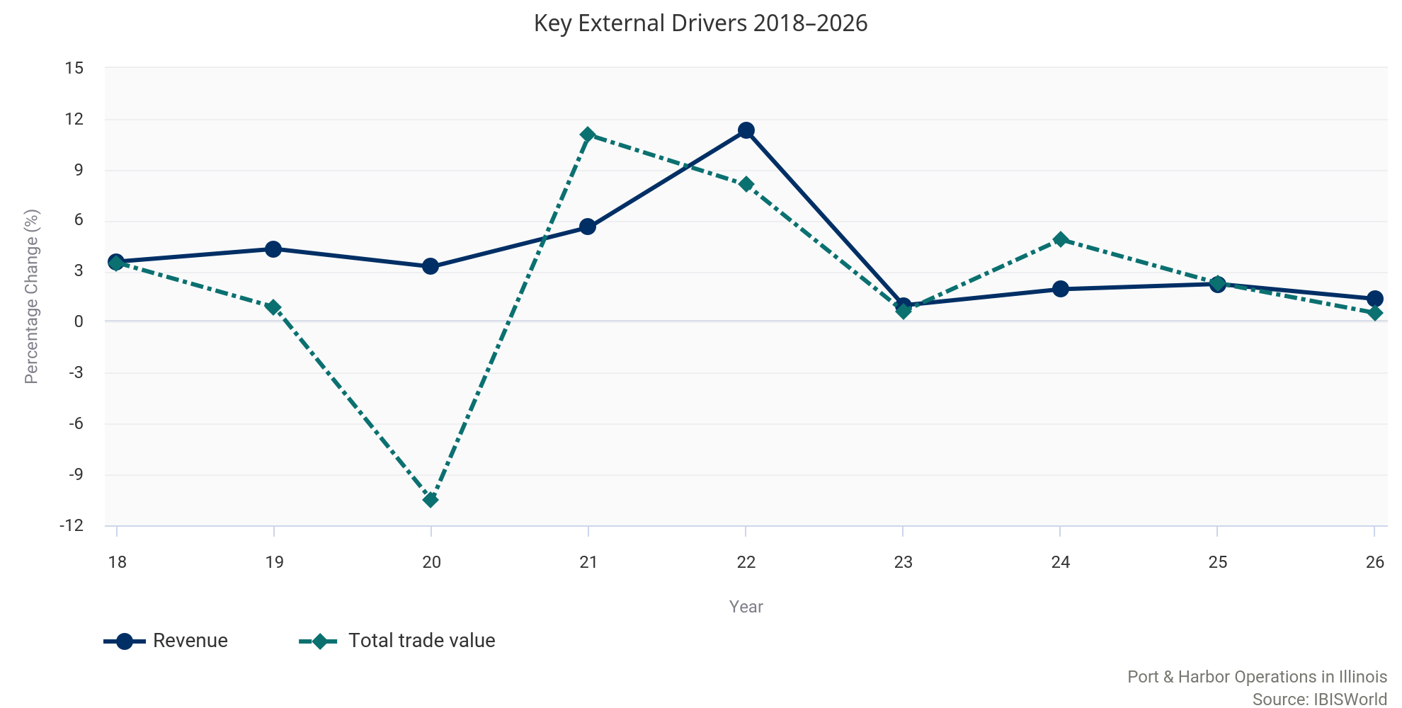

County Industry Data

Cook County  2 Est.  Most Establishments | Cook County  $37.6m  Highest Revenue | Gallatin County  20.0%  Fastest Growing | Lasalle County  -4.8%  Slowest Growing | Putnam County  $120.8k  Highest Average Wage | Cook County  81 Employees  Most Employees

Establishments
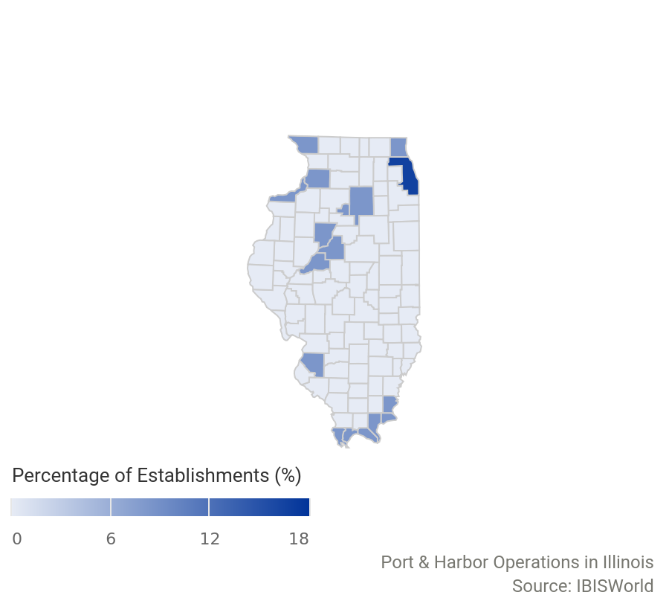 | County Establishments Annual Growth Rate (2025-26) Share of State  Cook County 2 0.0% 16.7%  Alexander County 1 0.0% 8.3%  Gallatin County 1 0.0% 8.3%  Hardin County 1 0.0% 8.3%  Jo Daviess County 1 0.0% 8.3%  Lake County 1 0.0% 8.3%  Lasalle County 1 0.0% 8.3%  Mason County 1 0.0% 8.3%  Massac County 1 0.0% 8.3%  Peoria County 1 0.0% 8.3%  The largest distribution of industry establishments in Illinois is concentrated in Cook County. Cook County accounts for 16.7% of the total establishments within the state.

The top 10 counties by highest establishments are displayed in the PDF version of this report. You can view insights for all counties associated with this industry on my.ibisworld.com.

Revenue
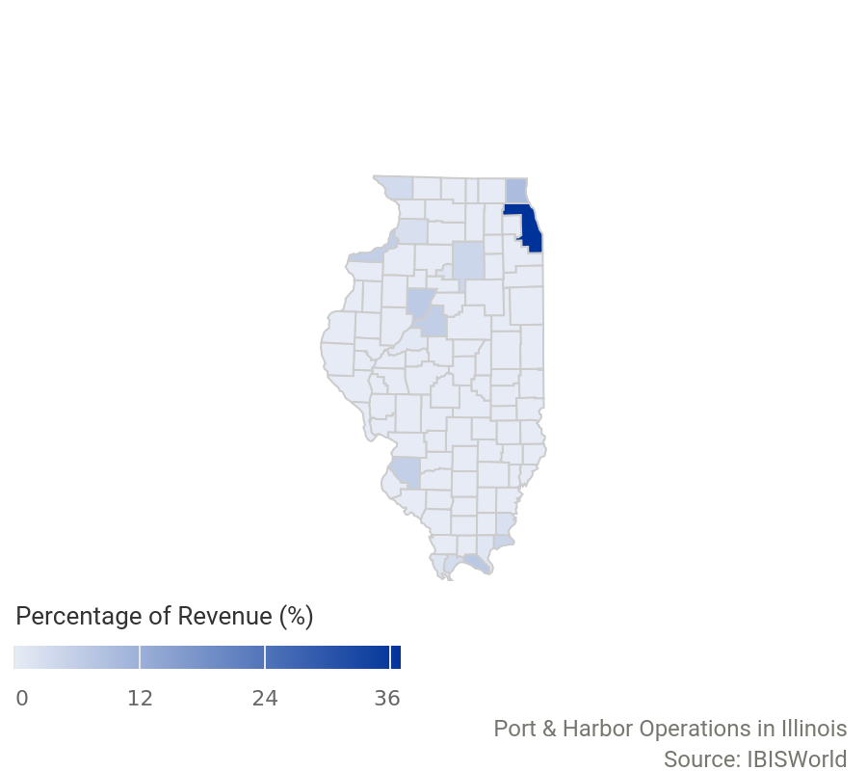 | County Revenue $ Annual Growth Rate (2025-26) Share of State  Cook County 37.6m 0.2% 37.0%  Lake County 9.6m 3.7% 9.4%  Massac County 7.1m 8.0% 7.0%  Peoria County 6.7m 3.9% 6.6%  Tazewell County 5.9m -1.9% 5.8%  St. Clair County 5.8m -1.0% 5.7%  Rock Island County 5.7m -0.8% 5.6%  Hardin County 4.5m 1.0% 4.4%  Lasalle County 4.3m -4.8% 4.3%  Jo Daviess County 3.3m -0.3% 3.3%  Cook County contributes most to the state industry's total revenue, with 37% of state revenue coming from the county.

The top 10 counties by highest revenue are displayed in the PDF version of this report. You can view insights for all counties associated with this industry on my.ibisworld.com.

Employment
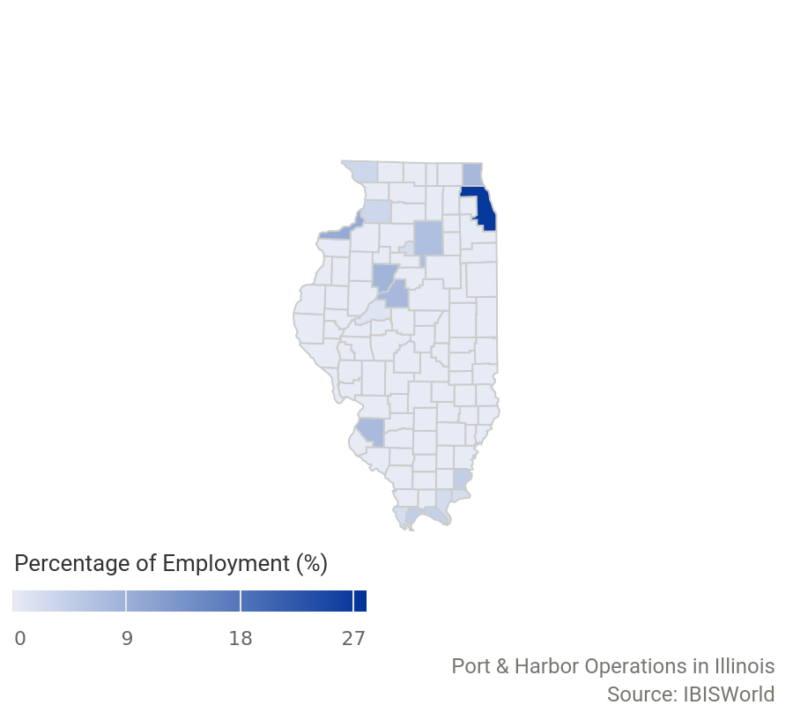 | County Employment Annual Growth Rate (2025-26) Share of State  Cook County 81 3.8% 27.2%  Rock Island County 29 3.6% 9.7%  Peoria County 25 8.7% 8.4%  Lake County 23 0.0% 7.7%  Tazewell County 23 0.0% 7.7%  St. Clair County 22 0.0% 7.4%  Lasalle County 20 0.0% 6.7%  Gallatin County 13 18.2% 4.4%  Pulaski County 13 0.0% 4.4%  Massac County 12 0.0% 4.0%  The largest number of industry employees in Illinois is concentrated in Cook County. Cook County employs 81 individuals - 27.2% of all state industry employees.

The top 10 counties by highest employment are displayed in the PDF version of this report. You can view insights for all counties associated with this industry on my.ibisworld.com.

Wages
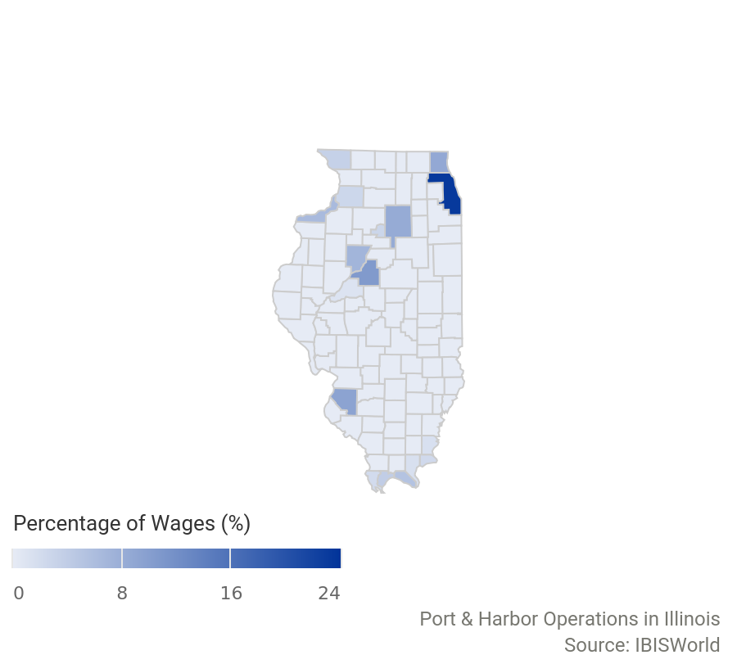 | County Wages $ Annual Growth Rate (2025-26) Share of State  Cook County 6.0m 0.0% 23.2%  Tazewell County 2.7m 9.5% 10.6%  St. Clair County 2.4m 8.9% 9.4%  Lake County 2.3m -5.5% 8.7%  Lasalle County 2.2m 9.7% 8.3%  Peoria County 1.8m -2.2% 7.1%  Rock Island County 1.6m -2.9% 6.4%  Massac County 1.4m 7.5% 5.3%  Pulaski County 999.0k 2.6% 3.9%  Jo Daviess County 888.7k 6.5% 3.4%  Cook County has spent the most on total wages within Illinois, with 23.2% of the state's total wages coming from the county.

The top 10 counties by highest wages are displayed in the PDF version of this report. You can view insights for all counties associated with this industry on my.ibisworld.com.

Key Statistics

State Industry Data
Year | Revenue  ($m) | Establishments  (Units) | Enterprises  (Units) | Employment  (Units) | Wages  ($m)
2007 | 34.3 | 8.00 | 7.00 | 127 | 9.72
2008 | 38.1 | 10.0 | 9.00 | 109 | 8.56
2009 | 48.1 | 9.00 | 8.00 | 99.0 | 7.57
2010 | 48.8 | 10.0 | 9.00 | 93.0 | 8.67
2011 | 51.3 | 9.00 | 8.00 | 95.0 | 8.88
2012 | 59.2 | 19.0 | 14.0 | 497 | 40.7
2013 | 64.2 | 14.0 | 12.0 | 136 | 12.0
2014 | 65.7 | 13.0 | 11.0 | 131 | 11.2
2015 | 70.6 | 12.0 | 11.0 | 152 | 12.0
2016 | 70.0 | 12.0 | 10.0 | 155 | 11.6
2017 | 72.6 | 12.0 | 10.0 | 174 | 13.5
2018 | 75.2 | 13.0 | 11.0 | 216 | 19.4
2019 | 78.5 | 13.0 | 11.0 | 244 | 21.3
2020 | 81.0 | 13.0 | 10.0 | 241 | 21.0
2021 | 85.6 | 13.0 | 10.0 | 247 | 22.8
2022 | 95.2 | 13.0 | 10.0 | 260 | 22.9
2023 | 96.2 | 12.0 | 10.0 | 272 | 23.8
2024 | 98.1 | 12.0 | 10.0 | 282 | 24.5
2025 | 100 | 12.0 | 10.0 | 291 | 25.3
2026 | 102 | 12.0 | 11.0 | 298 | 25.9
2027 | 104 | 12.0 | 11.0 | 305 | 26.6
2028 | 106 | 12.0 | 11.0 | 312 | 27.4
2029 | 108 | 13.0 | 10.0 | 320 | 28.2
2030 | 110 | 13.0 | 10.0 | 329 | 28.9

Annual Change
Year | Revenue  (%) | Establishments  (%) | Enterprises  (%) | Employment  (%) | Wages  (%)
2008 | 10.9 | 25.0 | 28.6 | -14.2 | -11.9
2009 | 26.4 | -10.0 | -11.1 | -9.17 | -11.6
2010 | 1.37 | 11.1 | 12.5 | -6.06 | 14.6
2011 | 5.26 | -10.0 | -11.1 | 2.15 | 2.45
2012 | 15.4 | 111 | 75.0 | 423 | 358
2013 | 8.29 | -26.3 | -14.3 | -72.6 | -70.4
2014 | 2.35 | -7.14 | -8.33 | -3.68 | -7.24
2015 | 7.50 | -7.69 | 0.00 | 16.0 | 7.85
2016 | -0.85 | 0.00 | -9.09 | 1.97 | -3.67
2017 | 3.77 | 0.00 | 0.00 | 12.3 | 16.6
2018 | 3.57 | 8.33 | 10.0 | 24.1 | 43.4
2019 | 4.32 | 0.00 | 0.00 | 13.0 | 9.63
2020 | 3.27 | 0.00 | -9.09 | -1.23 | -1.47
2021 | 5.60 | 0.00 | 0.00 | 2.49 | 8.81
2022 | 11.3 | 0.00 | 0.00 | 5.26 | 0.64
2023 | 0.99 | -7.69 | 0.00 | 4.62 | 3.64
2024 | 1.94 | 0.00 | 0.00 | 3.68 | 3.08
2025 | 2.25 | 0.00 | 0.00 | 3.19 | 3.14
2026 | 1.37 | 0.00 | 10.0 | 2.41 | 2.43
2027 | 2.02 | 0.00 | 0.00 | 2.35 | 2.77
2028 | 1.99 | 0.00 | 0.00 | 2.30 | 3.01
2029 | 1.99 | 8.33 | -9.09 | 2.56 | 2.82
2030 | 1.75 | 0.00 | 0.00 | 2.81 | 2.55

Key Ratios
Year | Revenue per Employee  ($'000) | Employees per estab.  (Units) | Wages/  Revenue  (%) | Average Wages  ($)
2007 | 270 | 15.9 | 28.3 | 76,497
2008 | 349 | 10.9 | 22.5 | 78,530
2009 | 486 | 11.0 | 15.7 | 76,432
2010 | 524 | 9.30 | 17.8 | 93,236
2011 | 540 | 10.6 | 17.3 | 93,505
2012 | 119 | 26.2 | 68.7 | 81,906
2013 | 472 | 9.71 | 18.8 | 88,526
2014 | 501 | 10.1 | 17.0 | 85,251
2015 | 464 | 12.7 | 17.1 | 79,237
2016 | 452 | 12.9 | 16.6 | 74,850
2017 | 417 | 14.5 | 18.6 | 77,774
2018 | 348 | 16.6 | 25.8 | 89,816
2019 | 322 | 18.8 | 27.1 | 87,166
2020 | 336 | 18.5 | 25.9 | 86,957
2021 | 346 | 19.0 | 26.6 | 92,317
2022 | 366 | 20.0 | 24.1 | 88,260
2023 | 354 | 22.7 | 24.7 | 87,440
2024 | 348 | 23.5 | 25.0 | 86,934
2025 | 345 | 24.3 | 25.2 | 86,888
2026 | 341 | 24.8 | 25.5 | 86,906
2027 | 340 | 25.4 | 25.7 | 87,265
2028 | 339 | 26.0 | 25.9 | 87,877
2029 | 337 | 24.6 | 26.1 | 88,099
2030 | 334 | 25.3 | 26.3 | 87,876


IBISWorld helps you find the industry information you need – fast.
DISCLAIMER
This product has been supplied by IBISWorld Inc. (‘IBISWorld’) solely for use by its authorized licenses strictly in accordance with their license agreements with IBISWorld. IBISWorld makes no representation to any other person with regard to the completeness or accuracy of the data or information contained herein, and it accepts no responsibility and disclaims all liability (save for liability which cannot be lawfully disclaimed) for loss or damage whatsoever suffered or incurred by any other person resulting from the use of, or reliance upon, the data or information contained herein. Copyright in this publication is owned by IBISWorld Inc. The publication is sold on the basis that the purchaser agrees not to copy the material contained within it for other than the purchasers own purposes. In the event that the purchaser uses or quotes from the material in this publication – in papers, reports, or opinions prepared for any other person – it is agreed that it will be sourced to: IBISWorld Inc.

Copyright 2026 IBISWorld Inc.



